**CSO ASSIGNMENT 5**

Name-*Deepanshu Bansal*

*Roll No.-21084006*

*Department- EEE idd*

1)Write a program in C to store elements in an array and print it.

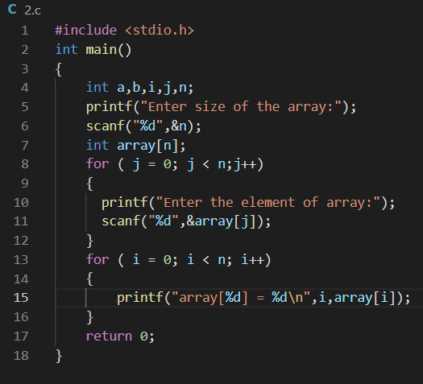

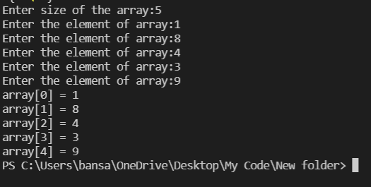

2)Write a program in C to find sum all elements of an array .

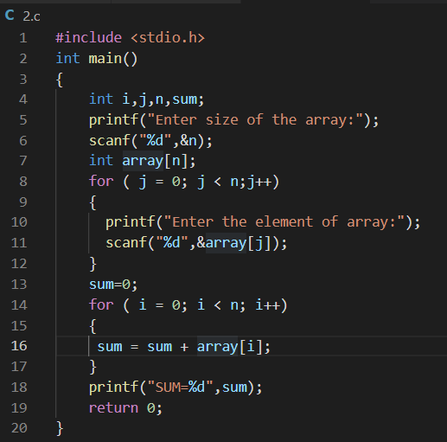

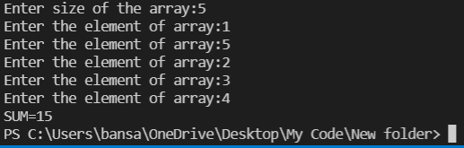

3)Write a program in c to find the maximum and minimum element in an array.

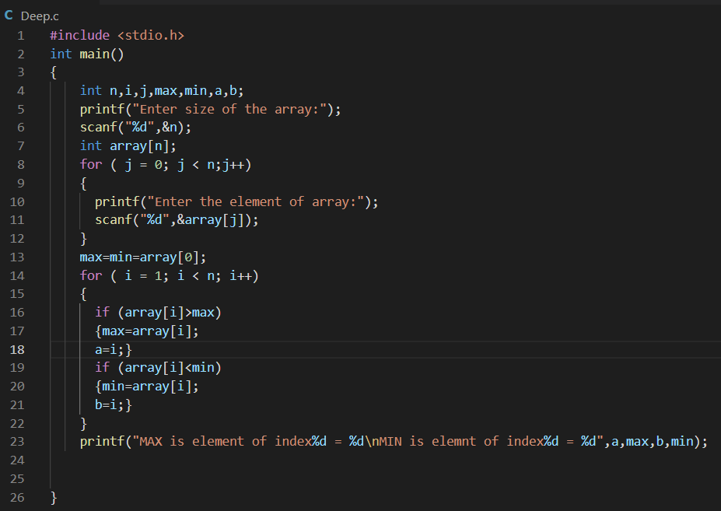

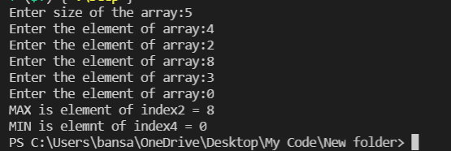

4) Write a program in C to find the frequency of each element in an array.

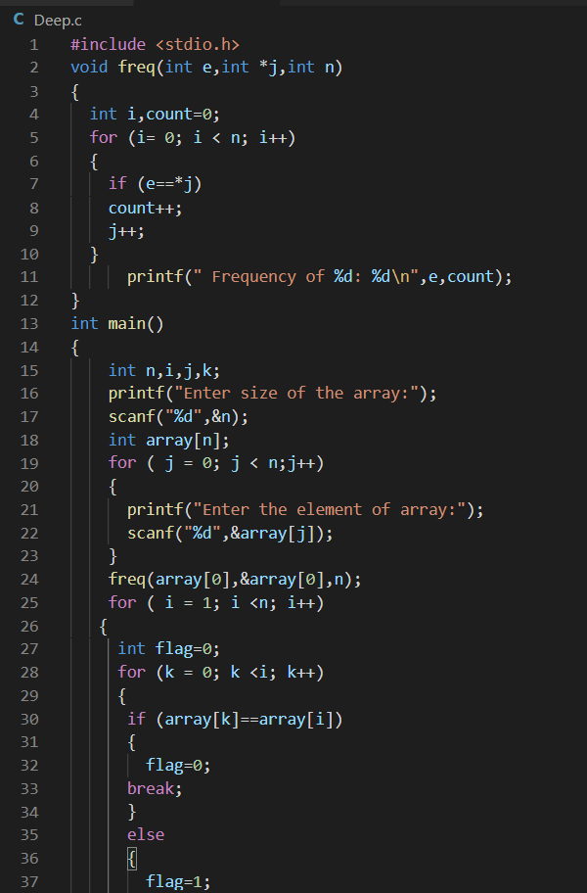

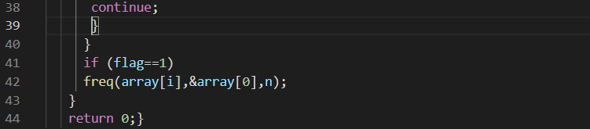

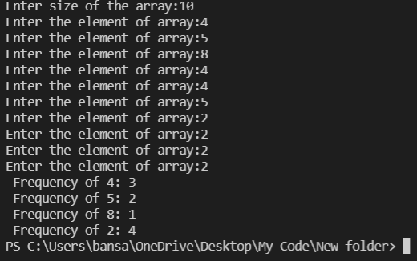

5)Write a program in C to find mean, median and mode of the elements of an array.

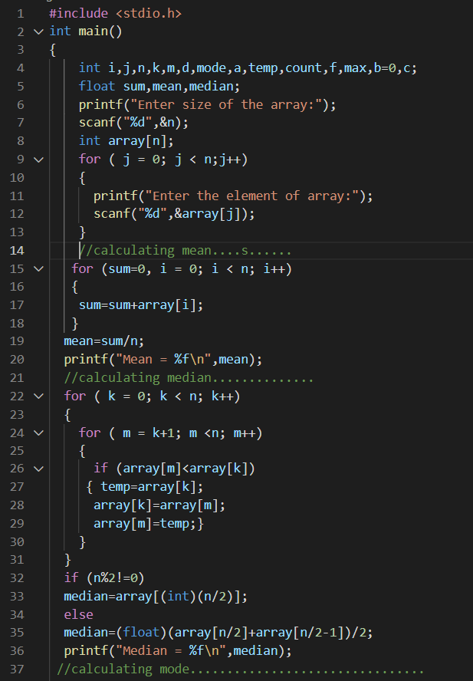  
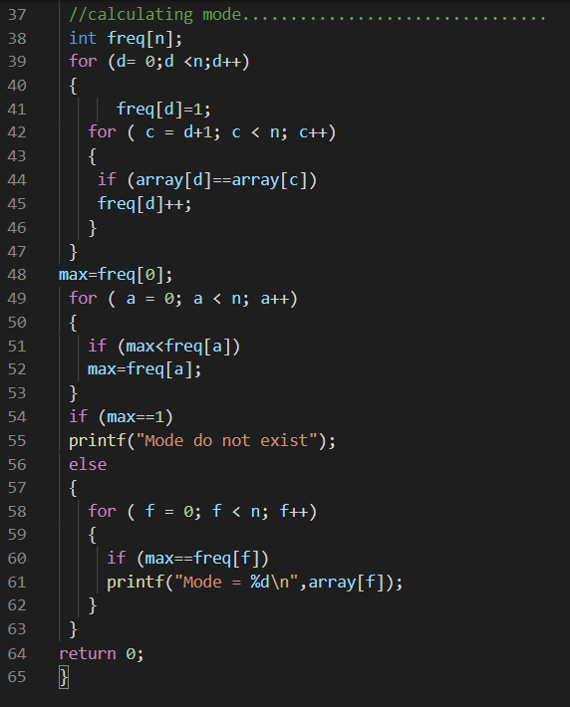  
  
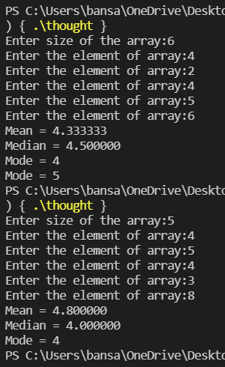

6)Write a program to separate odd and even integers in separate arrays.  
Ans. The code is as follows:   
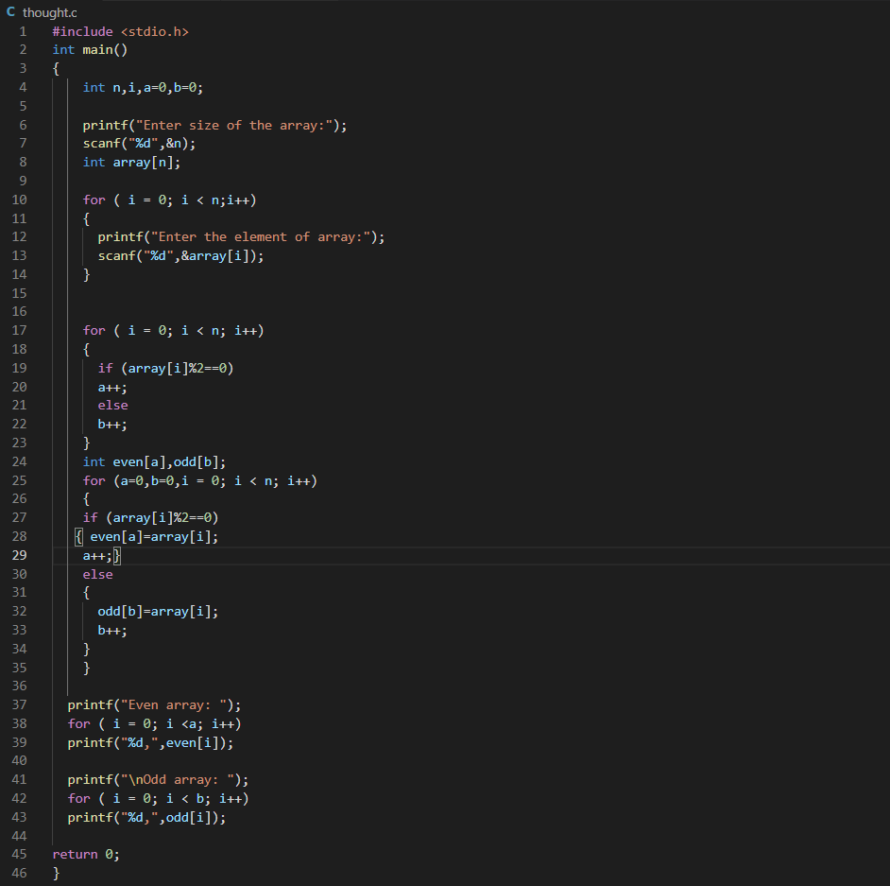  
  
  
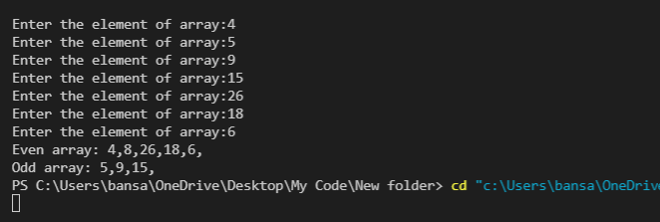

7)Write a program in C to display a Fibonacci series up to 10th term.

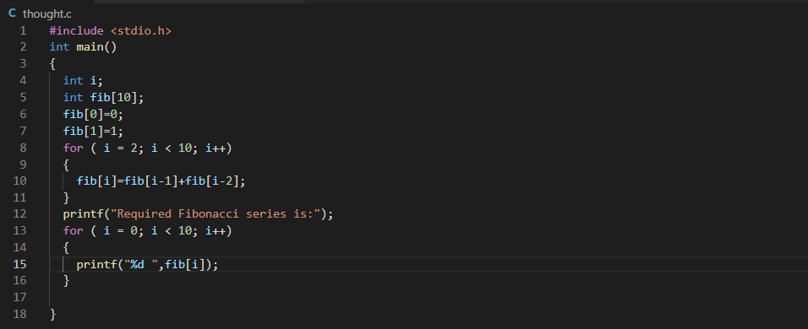



8)Write a program in C to sort a set of integers in ascending order.

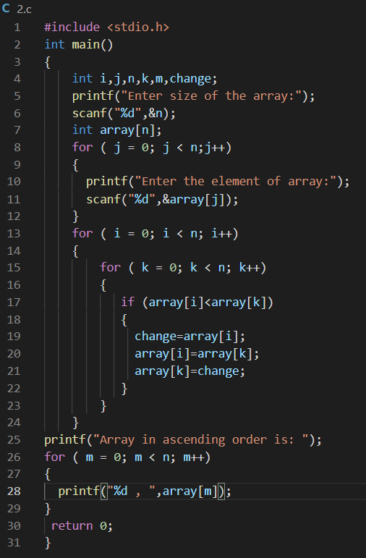

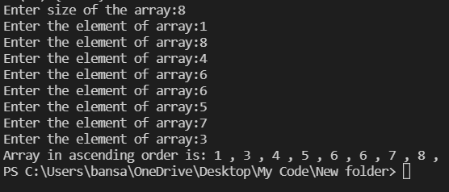

9)Write a program in C to input an integer array and an integer and find the index of the integer in that array.